**Outlier Detection Using Dataset having Outlier Label**

1. **Datasets obtained from UCI Machine Learning Repository**

* **Forest Cover Dataset**

Size : 286048 , Outliers : 2747

1. Isolation Forest

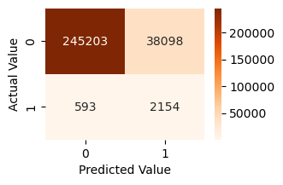

1. IQR

|  |  |  |
| --- | --- | --- |
| Threshold | Detected Outliers | Actual Outliers |
| 10.0 | 44907 | 2202 |
| 20.0 | 8767 | 306 |
| 30.0 | 1863 | 78 |
| 40.0 | 576 | 90 |
| 50.0 | 36 | 20 |
| 60.0 | 0 | 0 |
| 70.0 | 0 | 0 |
| 80.0 | 0 | 0 |
| 90.0 | 0 | 0 |
| 100.0 | 0 | 0 |

* **Shuttle Dataset**

Size : 49097, Outliers : 3511

1. Isolation Forest

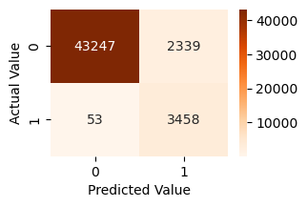

1. IQR

|  |  |  |
| --- | --- | --- |
| Threshold | Detected Outliers | Actual Outliers |
| 11.11 | 23797 | 30 |
| 22.22 | 10292 | 47 |
| 33.33 | 2880 | 76 |
| 44.44 | 1152 | 258 |
| 55.56 | 1166 | 961 |
| 66.67 | 1519 | 1498 |
| 77.78 | 584 | 582 |
| 88.89 | 59 | 59 |
| 100.00 | 0 | 0 |

* **Synthetic Outlier Dataset**

Size : 11000, Outliers : 1100

1. Isolation Forest

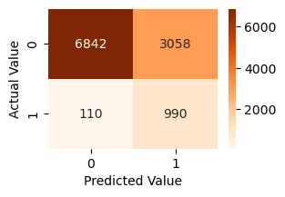

1. IQR

|  |  |  |
| --- | --- | --- |
| Threshold (%) | Detected Outliers | Actual Outliers |
| 10.0 | 0 | 0 |
| 20.0 | 0 | 0 |
| 30.0 | 0 | 0 |
| 40.0 | 0 | 0 |
| 50.0 | 0 | 0 |
| 60.0 | 0 | 0 |
| 70.0 | 0 | 0 |
| 80.0 | 0 | 0 |
| 90.0 | 0 | 0 |
| 100.0 | 0 | 0 |

* **Mammography Dataset**

Size : 11183, Outliers : 260

1. Isolation Forest

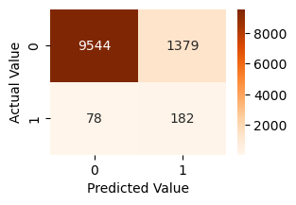

1. IQR

|  |  |  |
| --- | --- | --- |
| Threshold (%) | Detected Outliers | Actual Outliers |
| 16.67 | 3488 | 183 |
| 33.33 | 677 | 22 |
| 50.00 | 36 | 11 |
| 66.67 | 5 | 5 |
| 83.33 | 0 | 0 |
| 100.00 | 0 | 0 |

* **Satellite Dataset**

Size : 6435, Outliers : 2036

1. Isolation Forest

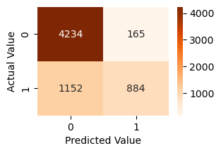

1. IQR

|  |  |  |
| --- | --- | --- |
| Threshold | Detected Outliers | Actual Outliers |
| 2.78 | 109 | 105 |
| 5.56 | 70 | 70 |
| 8.33 | 49 | 49 |
| 11.11 | 43 | 43 |
| 13.89 | 60 | 60 |
| 16.67 | 37 | 37 |
| 19.44 | 31 | 31 |
| 22.22 | 39 | 39 |
| 25.00 | 104 | 104 |
| 27.78 | 0 | 0 |
| 30.56 | 0 | 0 |
| 33.33 | 0 | 0 |
| 36.11 | 0 | 0 |
| 38.89 | 0 | 0 |
| 41.67 | 0 | 0 |
| 44.44 | 0 | 0 |
| 47.22 | 0 | 0 |
| 50.00 | 0 | 0 |
| 52.78 | 0 | 0 |
| 55.56 | 0 | 0 |
| 58.33 | 0 | 0 |
| 61.11 | 0 | 0 |
| 63.89 | 0 | 0 |
| 66.67 | 0 | 0 |
| 69.44 | 0 | 0 |
| 72.22 | 0 | 0 |
| 75.00 | 0 | 0 |
| 77.78 | 0 | 0 |
| 80.56 | 0 | 0 |
| 83.33 | 0 | 0 |
| 86.11 | 0 | 0 |
| 88.89 | 0 | 0 |
| 91.67 | 0 | 0 |
| 94.44 | 0 | 0 |
| 97.22 | 0 | 0 |
| 100.00 | 0 | 0 |

* **Thyroid Dataset**

Size : 3772, Outliers : 93

1. Isolation Forest

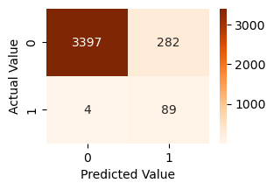

1. IQR

|  |  |  |
| --- | --- | --- |
| Threshold | Detected Outliers | Actual Outliers |
| 16.67 | 608 | 16 |
| 33.33 | 197 | 21 |
| 50.00 | 91 | 17 |
| 66.67 | 48 | 39 |
| 83.33 | 0 | 0 |
| 100.00 | 0 | 0 |

* **Ann thyroid Dataset**

Size : 7200, Outliers : 534

1. Isolation Forest

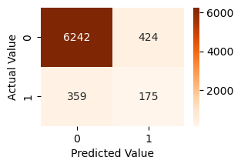

1. IQR

|  |  |  |
| --- | --- | --- |
| Threshold | Detected Outliers | Actual Outliers |
| 16.67 | 1299 | 356 |
| 33.33 | 394 | 74 |
| 50.00 | 182 | 46 |
| 66.67 | 63 | 52 |
| 83.33 | 6 | 6 |
| 100.00 | 0 | 0 |

* **Satimage-2 Dataset**

Size : 5803, Outliers : 71

1. Isolation Forest

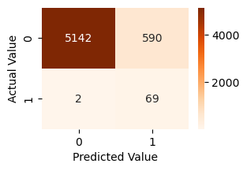

1. IQR

|  |  |  |
| --- | --- | --- |
| Threshold | Detected Outliers | Actual Outlier |
| 2.78 | 45 | 4 |
| 5.56 | 13 | 3 |
| 8.33 | 5 | 4 |
| 11.11 | 6 | 6 |
| 13.89 | 2 | 1 |
| 16.67 | 3 | 3 |
| 19.44 | 7 | 7 |
| 22.22 | 7 | 7 |
| 25.00 | 1 | 1 |
| 27.78 | 5 | 5 |
| 30.56 | 4 | 4 |
| 33.33 | 2 | 2 |
| 36.11 | 2 | 2 |
| 38.89 | 5 | 5 |
| 41.67 | 3 | 3 |
| 44.44 | 2 | 2 |
| 47.22 | 2 | 2 |
| 50.00 | 2 | 2 |
| 52.78 | 0 | 0 |
| 55.56 | 0 | 0 |
| 58.33 | 0 | 0 |
| 61.11 | 0 | 0 |
| 63.89 | 0 | 0 |
| 66.67 | 0 | 0 |
| 69.44 | 0 | 0 |
| 72.22 | 0 | 0 |
| 75.00 | 0 | 0 |
| 77.78 | 0 | 0 |
| 80.56 | 0 | 0 |
| 83.33 | 0 | 0 |
| 86.11 | 0 | 0 |
| 88.89 | 0 | 0 |
| 91.67 | 0 | 0 |
| 94.44 | 0 | 0 |
| 97.22 | 0 | 0 |
| 100.00 | 0 | 0 |